Steve Korsmeyer  County Clerk  Dawn Cremeans  Chief Deputy Clerk  Michele Derleth  Lead Deputy Clerk | 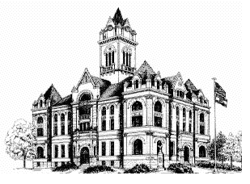  Cole County Clerk  311 E High St. Room 201  Jefferson City, MO 65101  (573)634-9101 Fax (573)681-9678 | Dana Boyd  Accounts Payable Specialist  Matt Musselman  Director of Elections  Chloe Craig-Baker  Tax Specialist

Request to be Removed from the Cole County Voter Registration List
I, the undersigned, do hereby certify that I have moved out of Cole County, or no longer wants to be a registered voter in Cole County, and request to be removed from the Cole County Voter Registration List:
Name: _____________________________ _________________ ________________________________ (First) (Middle) (Last)
Date of Birth: ____________________ Last 4 Digits of SSN: _______________
Address on Last Registration: ___________________________________________________________________ (Number) (Street) (City) (ZIP)

SIGNATURE REQUIRED: ___________________________________________ DATE: __________________
Please note: Signature is required for all updates to voter registration records.

Please print and return your form by:
- Mail: Cole County Clerk, 311 E High St. Room 201, Jefferson City, MO 65101
- Email: skorsmeyer@colecounty.org; or
- Fax: 573-681-9678

